--

News From

Mrs. Neighbors

|  |
| --- |
| **What are we learning?** |
| **Reading:**  Students will practice reading passages and writing answers in paragraph format, using textual information to support their answers. We will also study different poetry genres, review elements of poetry and write responses to poem comprehension questions. This will help prepare for upcoming state testing.  **Language/Writing:**  We will focus on using negatives (don’t, nobody, nothing) and prepositional phrases.  **Math:**  We will beginTopic 10, multiplying fractions and solving time word problems. Look for a study guide to come home on Thursday for a test planned the following week.  **Science:**  Students should use the study guide to prepare for the test on February 24th. We will begin minilessons on different topics including the human body systems, topographic maps and information transfer to prepare for ACAP testing content.  **AL History:**  Students will begin learning about life during and after the Reconstruction Era. They will understand the changes in education, industry, religion and commerce. |
|  |
|  |
|  |

_______________________________________________________

_______________________________________________________

_______________________________________________________

_______________________________________________________

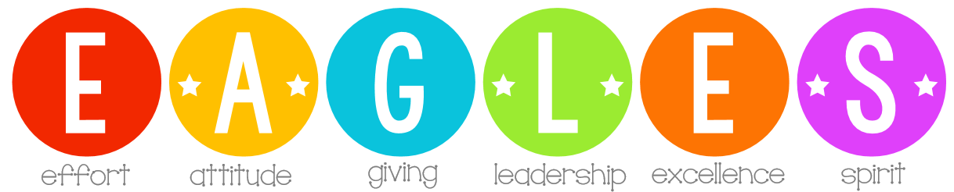

**Dates to Remember:**

* February 24th – March 6th:

4th Grade Enrichment Pet Supply Drive

* Tues., February 25th:

Montgomery Field Trip

* Thurs., February 27th :

Restaurant Night @ Moe's BBQ Bent CreeK

* Fri., February 28th :

Read to a Kid Day (Be thinking of a book character costume!)

### Week of:

### Feb. 24th–28th



**Lee County Humane Society**

**Pet Supply Drive**

**February 24 – March 6**



MCj03979950000[1]

**This Tuesday! Montgomery Field Trip**

Students should wear comfortable walking shoes and their EAGLES shirt. **Only throw away** water bottles and containers allowed this day. Students can bring a snack and drink to have on the bus traveling to Montgomery (separate from lunch.) I will provide a snack and drink for the bus ride home. Students do not need to carry money, cameras/cell phones. We will return to WMR **after normal school hours**. Please be prepared for the 4:00 pick up time!

We are excited to see all the book characters on February 28th, Read to a Kid Day! Students are encouraged to dress as a favorite book character and parents are invited to pop in to take Students to the café where books are the only things on the menu! Parents are invited to read to their student anytime from 8:45 -1:00. There will also be PE and recess, so make sure the costumes are flexible!

